| **Project Name** | Optimizing Appointment Scheduling to Minimize Gaps and Maximize Revenue |
| --- | --- |
| **Today’s Date** | 05/05/2025 |
| **Project Start Date** | 05/05/2025 |
| **Target Completion Date** | 06/05/2025 |

| **Project Element** | **Response** | | | |
| --- | --- | --- | --- | --- |
| **Problem Statement**   * Includes time, measurable item, gap and business impact | Currently, the appointment schedule shows an average of 15% of appointment slots going unfilled per week (measurable item, gap). This results in an estimated $5,000 per week in lost revenue (business impact). Analysis of historical data shows that 20% of patients cancel their appointments with less than 24 hours' notice, and these slots are difficult to fill (time) | | | |
| **Business Case**   * Why is this project important to do now? * What is the project’s financial impact? * What is the impact on DPMO/ Sigma level? * What is the impact on customer service | This project is crucial now because the increasing financial pressure on the clinic requires maximizing revenue from available appointment slots. Additionally, unfilled slots represent a missed opportunity to provide timely patient care, potentially impacting patient satisfaction and health outcomes.  Reducing unfilled slots by 50% would result in an estimated increase in weekly revenue of $2,500, totaling $130,000 annually. This does not include potential revenue from new patients who can be seen sooner.  By reducing the number of unfilled slots (defects), we will decrease the Defects Per Million Opportunities (DPMO) related to scheduling inefficiency. This will improve the sigma level of the scheduling process, indicating a higher level of process capability.  Optimizing the schedule will allow for more efficient appointment booking, reducing wait times for patients who need to be seen. It will also minimize the frustration of patients whose appointments are canceled and not replaced, leading to increased patient satisfaction. | | | |
| **Goal Statement**   * Specific * Measurable * Achievable * Realistic * Time-bound | To optimize the appointment scheduling process by reducing the number of unfilled appointment slots by 50% and increasing weekly revenue by $2,500 within the next 12 weeks. | | | |
| **List of Improvement Goals**  1.Reduce unfilled appointment slots.  2.Increase weekly revenue  3.Decrease # of appts canceled  4.Develop a predictive model to identify appointments at high risk of cancellation  5.Implement a double-booking protocol for high-risk appointment slots, balancing risk and potential revenue gain | **Measure (units)** | **Baseline** | | **Goal** |
| Unfilled Slots | 15% | | 7.5% |
| $ per week | 10k | | 10.5k |
| # of appointments | 8 | | 4 |
| none | none | | none |
| none | none | | none |
| **Process**   * Describe the process in which the problem exists | The current appointment scheduling process involves patients contacting the clinic via phone or online portal to request appointments. Staff manually enter these appointments into the electronic health record (EHR) system. Cancellations are handled on an ad-hoc basis, with staff attempting to fill the slots, often unsuccessfully. Double-booking is rarely used and not based on data-driven decisions. | | | |
| **Project Scope**   * What part of the process will be addressed? * What are the boundaries of the project or process? * What areas are inside or outside the team’s focus or authority? * Attach a SIPOC diagram if necessary | This project will address the appointment scheduling process from the point of a patient scheduling an appointment to the point of the appointment occurring (or not occurring due to cancellation). It will specifically focus on analyzing historical appointment data, cancellation patterns, and slot utilization  The project boundaries include:   * Analyzing appointment data from the past 6 months. * Developing a predictive model for appointment cancellations. * Implementing a revised double-booking protocol. * Measuring the impact of the changes on revenue and slot utilization over a 3-month period after implementation   **Inside:** Data analysis, predictive model development, protocol design, implementation of the new scheduling protocol, and measurement of results.  **Outside:** Changes to physician schedules, marketing efforts to attract new patients, and changes to the electronic health record (EHR) system (unless minor and directly related to data extraction).  Not necessary. | | | |
| **Team** | **Member Name** | | | |
| Project Sponsor | Regional Vice President | | | |
| Key Stakeholders | Population Health Director / Regional Director of Operations | | | |
| Team Lead | Data Scientist/Analyst | | | |
| Team Members | Lead Clinical Informatics Specialists | | | |
| Process Owner | Practice Manager | | | |
| Other |  | | | |
| **Timeline by Project Stage** | **Milestone** | | **Target Completion Date** | |
| Define | Project Charter and kickoff | | 05/05/2025 | |
| Measure | Define and collect data | | 05/10/2025 | |
| Analysis | Find causes | | 05/17/2025 | |
| Improve | Fix causes | | 05/24/2025 | |
| Control | Standardize the fix | | 06/02/2025 | |

| **Project Title** | Optimizing Appointment Scheduling to Minimize Gaps and Maximize Revenue |  |  |
| --- | --- | --- | --- |
|  |  |  |  |
| **Expectation** | **Example** | **Team Rule** |  |
| Attendance | **Attendance is required at all team meetings. Changes in meeting times must be made at least 24 hours ahead of time.** | All members will attend scheduled meetings on Mondays at 10:00 AM unless prior notification (at least 24 hours) is given to the Team Lead. If a scheduling conflict arises, the member is responsible for catching up on missed information. |  |
| Participation | **Team members may not be substituted unless approved by team leader.** | Each team member will actively contribute their expertise during meetings and complete assigned tasks by the agreed-upon deadlines. The Data Scientist will lead data analysis discussions, and the Practice Manager will provide insights into daily operations. |  |
| Focus | **We will stay on task and on topic, using the Project Charter as our guide. A meeting agenda will be published at least one day in advance.** | Meeting agendas will be distributed by the Team Lead via email by Friday afternoon each week. Discussions will refer back to the Project Charter's objectives and scope to ensure we remain on track**.** |  |
| Interruptions | **Interruptions for emergencies only. Phones turned to silent.** | During meetings, team members will silence their mobile phones and only take calls for urgent matters. Designate a "parking lot" to jot down off-topic ideas for later discussion. |  |
| Preparation | **All deliverables are expected to be completed in a timely manner. Each meeting will have a published agenda.** | Team members are expected to review the meeting agenda and any pre-reading materials (e.g., data analysis reports, process maps) before each meeting. The Data Scientist will prepare data summaries for review. |  |
| Timeliness | **Meetings will begin promptly as scheduled.** | Meetings will commence promptly at 10:00 AM. Members should log in or arrive a few minutes early to ensure a smooth start. |  |
| Decisions | **We will choose the best decision-making method for each situation. We will support decisions made by the team.** | For most decisions, we will aim for consensus. If consensus cannot be reached, the Team Lead will facilitate a vote, and the majority decision will be supported by all team members. Critical decisions impacting resources or scope will require Project Sponsor approval. |  |
| Data | **We will rely on data to make decisions.** | All recommendations and proposed changes will be supported by data analysis conducted by the Data Scientist. The team will collectively review and interpret the data to inform our decisions. |  |
| Conflict | **We welcome honest disagreements, as long as everyone is treated with respect. A facilitator will be used if conflict cannot be resolved.** | We encourage open and respectful debate of ideas. If disagreements arise, team members will actively listen to understand different perspectives. If a resolution cannot be found within the team, the Project Sponsor will be consulted for guidance. |  |
| Other |  |  |  |
|  |  |  |  |
| **Team Member** | **Role** | **Signature** |  |
| Neil Truskolaski | **Data Scientist** | **NT** |  |
| Kasha O. | **Population Health Director** | **KO** |  |
| **Nikki F.** | **Regional Director of operations** | **NF** |  |
| Amy Q. | **Regional VP** | **AQ** |  |
| Angel V. | **Lead CIS** | **AV** |  |
| Michelle M. | **Practice Manager** | **MM** |  |
|  |  |  |  |

**Data Collection Plan**

To create a robust data collection plan, we need to define what data to collect, the type of data, and how to collect it. Here's a more detailed plan:

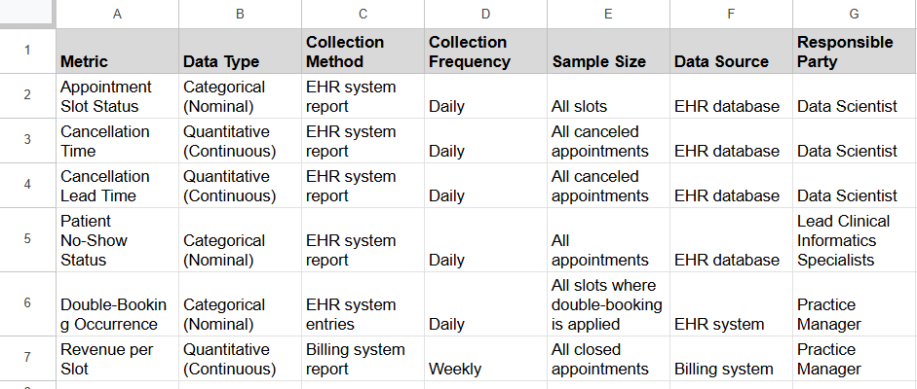

**Process Map**

Here's a basic process map for the current appointment scheduling process:

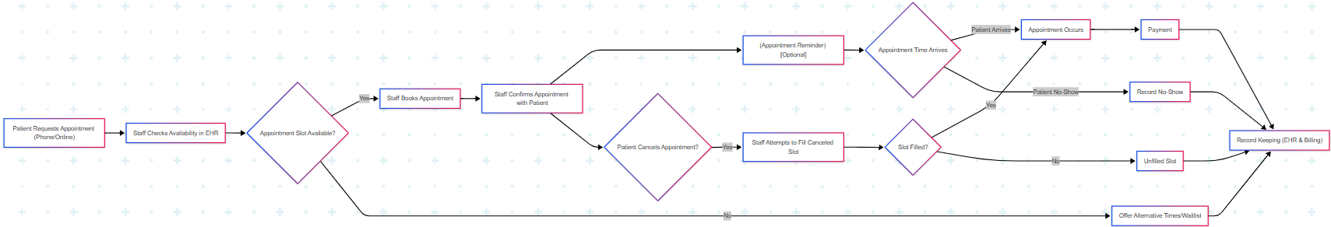

**5. Hypotheses**

Here are the null and alternative hypotheses:

* **For unfilled slots:**
  + H0: The proportion of unfilled appointment slots will not decrease after implementing the new scheduling process.
  + Ha: The proportion of unfilled appointment slots will decrease after implementing the new scheduling process.
* **For revenue:**
  + H0: The average revenue per week will not increase after implementing the new scheduling process.
  + Ha: The average revenue per week will increase after implementing the new scheduling process.
* **For cancellation lead time:**
  + H0: The average cancellation lead time will not change after implementing the new scheduling process.
  + Ha: The average cancellation lead time will increase after implementing the new scheduling process.

**Step 6: Analyze Your Data**

**Data**

* **Unfilled Slots:**
  + Week 1: 16%
  + Week 2: 14%
  + Week 3: 17%
  + Week 4: 13%
* **Cancellation Lead Time:** (in hours)
  + Cancellations: 20, 5, 48, 2, 24, 1, 72, 10, 16, 3
* **No-Show Status:**
  + Total Appointments: 200
  + No-Shows: 10
* **Double-Booking Occurrence:**
  + Slots Eligible for Double Booking: 50
  + Slots Double-Booked: 5
* **Revenue per Slot:**
  + Average Revenue per Filled Slot: $120
  + Average Revenue per Unfilled Slot: $0

**Analysis Examples**

* **Appointment Slot Status:**
  + The average weekly unfilled slot rate over the four weeks was 15% (calculated by averaging the weekly percentages).
  + A trend analysis shows a slight decrease in unfilled slots over the four weeks, from 16% in week 1 to 13% in week 4. This suggests a potential improvement even before implementing new interventions, but the variation is still significant.
* **Cancellation Lead Time:**
  + Descriptive statistics for cancellation lead time show a mean of 18.1 hours and a median of 8 hours, with a standard deviation of 24.8 hours. This indicates a wide range of cancellation lead times and a right-skewed distribution, meaning most cancellations occur close to the appointment time.
  + A histogram of cancellation lead times confirms the right-skew, with the majority of cancellations occurring within 24 hours. 60% of cancellations occurred within 24 hours, 20% between 24 and 48 hours, and 20% beyond 48 hours.
* **No-Show Status:**
  + The overall no-show rate was 5% (10 no-shows out of 200 appointments).
* **Double-Booking Occurrence:**
  + Double-booking was applied to 10% of eligible slots (5 out of 50).
  + Revenue analysis shows that unfilled slots result in a 100% loss of potential revenue, or $120 per slot.

**Step 7: Identify Possible Improvements and Select One**

* **Improvement 1: Automated Appointment Reminders**
  + Rationale: The high percentage of cancellations within 24 hours suggests that patients may be forgetting their appointments. Automated reminders could increase lead time.
* **Improvement 2: Refined Double-Booking Protocol**
  + Rationale: Only 10% of eligible slots are double-booked. A refined protocol could increase this percentage, reducing revenue loss from unfilled slots, especially given the 100% revenue loss from unfilled slots.
* **Improvement 3: Proactive Cancellation Management**
  + Rationale: Analysis of cancellation patterns might reveal specific patient demographics or appointment types with higher cancellation rates. Proactive calls to these patients could reduce cancellations.

**Selected Improvement Example**

**Improvement 1: Automated Appointment Reminders.**

* We have selected the implementation of an automated appointment reminder system as our primary improvement. This is based on the analysis showing that 60% of cancellations occur within 24 hours, indicating that reminders could significantly impact this metric and reduce the number of unfilled slots.

**Step 8: Develop a Control Plan**

The following control plan outlines the monitoring and control mechanisms to ensure the sustainability of the implemented automated appointment reminder system. It defines the key characteristics to be monitored, their target performance levels, measurement methods, monitoring frequency, control tools, responsible parties, and the actions to be taken if deviations from the target performance occur. 1 This plan is designed to maintain the improvements achieved in reducing unfilled appointment slots and improving patient satisfaction.

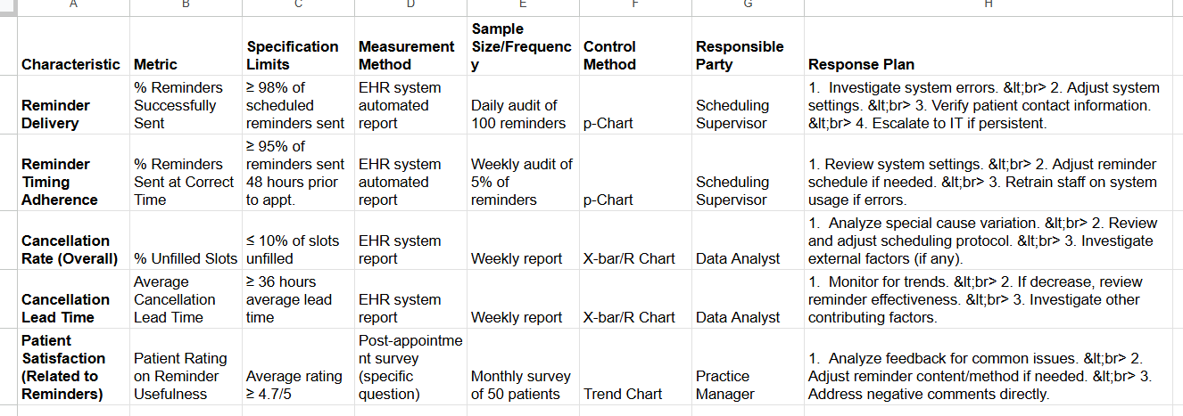

**Step 9: Reflection**

The Green Belt training deepened my understanding of DMAIC, especially the power of rigorous data analysis. In this project, tools like histograms and control charts transformed raw data into insights about short-notice cancellations and their impact on slot utilization, highlighting the need for precise data and statistical analysis.

Collaboration was key to this project's success. Combining the clinical perspective of the Practice Manager with the data analysis skills of the Data Scientist provided a comprehensive view of the scheduling problem and fostered shared ownership of the solution.